New code Q-Learning
import numpy as np
import matplotlib.pyplot as plt
import pickle
from collections import defaultdict

class MaintenanceSchedulingEnv:
"""
Environment for Proactive Maintenance Scheduling
Simpler version optimized for Q-learning (discrete states)
"""
def __init__(self):
# Simulation parameters
self.max_steps = 100
self.current_step = 0

# Action space: 0=do nothing, 1=immediate, 2=schedule low-load,
# 3=schedule 3 days, 4=schedule 7 days
self.n_actions = 5

# Weights for multi-objective optimization
self.w_downtime = 1.0
self.w_cost = 0.5
self.w_risk = 2.0

self.reset()

def reset(self):
"""Reset environment to initial state"""
# Initialize with realistic scenarios
self.time_to_failure = np.random.uniform(5, 30) # days
self.severity = np.random.uniform(0.3, 1.0)
self.resource_avail = np.random.uniform(0.5, 1.0)
self.production_load = np.random.uniform(0.2, 0.95)
self.time_since_last = np.random.uniform(0, 20)

self.current_step = 0
self.total_downtime = 0
self.total_cost = 0
self.failures_prevented = 0
self.failures_occurred = 0

return self._get_state()

def _get_state(self):
"""
Convert continuous state to discrete state for Q-learning
Returns a tuple that can be used as dictionary key
"""
# Discretize each variable into bins
ttf_bin = min(4, int(self.time_to_failure / 7)) # 0-4 (0-7d, 7-14d, 14-21d, 21-28d, 28+d)
severity_bin = min(2, int(self.severity / 0.34)) # 0-2 (low, medium, high)
resource_bin = 1 if self.resource_avail > 0.7 else 0 # 0-1 (low, high)
prod_bin = min(2, int(self.production_load / 0.34)) # 0-2 (low, medium, high)
last_maint_bin = min(3, int(self.time_since_last / 7)) # 0-3 (recent to old)

return (ttf_bin, severity_bin, resource_bin, prod_bin, last_maint_bin)

def step(self, action):
"""Execute action and return next state, reward, done, info"""
reward = 0
done = False

# Calculate priority for context
if self.time_to_failure <= 0:
urgency = 10.0
else:
urgency = 1.0 / max(0.1, self.time_to_failure)

production_conflict = self.production_load * 0.5
priority = (0.4 * self.severity + 0.5 * urgency - 0.1 * production_conflict)

# Execute action
if action == 1: # Immediate maintenance
downtime_cost = self.production_load * 10
resource_cost = 5 * (2.0 - self.resource_avail)
maintenance_cost = 8
total_cost = downtime_cost + resource_cost + maintenance_cost

risk_reduction_reward = 30 * self.severity * (1.0 - self.time_to_failure / 30.0)

reward = (risk_reduction_reward * self.w_risk -
downtime_cost * self.w_downtime -
maintenance_cost * self.w_cost)

self.time_to_failure = np.random.uniform(20, 30)
self.time_since_last = 0
self.total_downtime += 1
self.total_cost += total_cost
self.failures_prevented += 1

elif action == 2: # Schedule during low-load window
if self.production_load < 0.4:
reward = 25 * self.severity - 4 * self.w_cost
self.time_to_failure = np.random.uniform(20, 30)
self.time_since_last = 0
self.total_downtime += 0.5
self.total_cost += 4
self.failures_prevented += 1
else:
reward = -8
self.time_to_failure -= 1

elif action == 3: # Schedule in 3 days
scheduling_reward = 5 if self.time_to_failure > 5 else -10
reward = scheduling_reward
self.time_to_failure -= 1

elif action == 4: # Schedule in 7 days
if self.time_to_failure > 10:
reward = 8
else:
reward = -15
self.time_to_failure -= 1

else: # Do nothing (action 0)
urgency_penalty = (1.0 - self.time_to_failure / 30.0) * self.severity * 5
reward = -urgency_penalty * self.w_risk
self.time_to_failure -= 1

# Natural system evolution
self.time_since_last += 1
self.production_load = np.clip(
self.production_load + np.random.uniform(-0.1, 0.1), 0.2, 0.95
)
self.resource_avail = np.clip(
self.resource_avail + np.random.uniform(-0.05, 0.05), 0.5, 1.0
)

# Critical failure check
if self.time_to_failure <= 0:
failure_penalty = 100 * self.severity * self.w_risk
downtime_penalty = 20 * self.production_load * self.w_downtime
reward -= (failure_penalty + downtime_penalty)

self.failures_occurred += 1
self.total_downtime += 5
self.total_cost += 50

self.time_to_failure = np.random.uniform(15, 25)
self.time_since_last = 0

# Episode termination
self.current_step += 1
if self.current_step >= self.max_steps:
done = True

next_state = self._get_state()

info = {
'total_downtime': self.total_downtime,
'total_cost': self.total_cost,
'failures_prevented': self.failures_prevented,
'failures_occurred': self.failures_occurred,
'priority': priority
}

return next_state, reward, done, info

class QLearningAgent:
"""
Q-Learning Agent for Maintenance Scheduling
Uses table-based Q-learning (no neural networks needed)
"""
def __init__(self, n_actions, learning_rate=0.1, discount_factor=0.99,
epsilon_start=1.0, epsilon_end=0.01, epsilon_decay=0.995):
self.n_actions = n_actions
self.lr = learning_rate # How fast to learn (alpha)
self.gamma = discount_factor # How much to value future rewards
self.epsilon = epsilon_start # Exploration rate
self.epsilon_end = epsilon_end
self.epsilon_decay = epsilon_decay

# Q-table: stores Q(state, action) values
# Using defaultdict so we don't need to pre-initialize all states
self.q_table = defaultdict(lambda: np.zeros(n_actions))

# Statistics
self.episode_rewards = []
self.episode_lengths = []
self.epsilon_history = []

def get_action(self, state, training=True):
"""
Choose action using epsilon-greedy strategy
- With probability epsilon: explore (random action)
- With probability 1-epsilon: exploit (best known action)
"""
if training and np.random.random() < self.epsilon:
# Explore: random action
return np.random.randint(self.n_actions)
else:
# Exploit: best action according to Q-table
return np.argmax(self.q_table[state])

def update(self, state, action, reward, next_state, done):
"""
Update Q-table using Q-learning update rule:
Q(s,a) ← Q(s,a) + α[r + γ·max(Q(s',a')) - Q(s,a)]
"""
current_q = self.q_table[state][action]

if done:
# If episode is done, there's no future reward
target_q = reward
else:
# Target = immediate reward + discounted future reward
max_next_q = np.max(self.q_table[next_state])
target_q = reward + self.gamma * max_next_q

# Update Q-value
self.q_table[state][action] = current_q + self.lr * (target_q - current_q)

def decay_epsilon(self):
"""Reduce exploration rate over time"""
self.epsilon = max(self.epsilon_end, self.epsilon * self.epsilon_decay)

def save(self, filename):
"""Save Q-table to file"""
with open(filename, 'wb') as f:
pickle.dump({
'q_table': dict(self.q_table),
'epsilon': self.epsilon,
'episode_rewards': self.episode_rewards
}, f)
print(f"Agent saved to {filename}")

def load(self, filename):
"""Load Q-table from file"""
with open(filename, 'rb') as f:
data = pickle.load(f)
self.q_table = defaultdict(lambda: np.zeros(self.n_actions), data['q_table'])
self.epsilon = data['epsilon']
self.episode_rewards = data.get('episode_rewards', [])
print(f"Agent loaded from {filename}")

def train_agent(env, agent, n_episodes=1000, verbose=True):
"""Train the Q-learning agent"""
print("=" * 70)
print("STARTING Q-LEARNING TRAINING")
print("=" * 70)
print(f"Episodes: {n_episodes}")
print(f"Learning rate: {agent.lr}")
print(f"Discount factor: {agent.gamma}")
print(f"Exploration: {agent.epsilon} → {agent.epsilon_end}")
print("=" * 70)

for episode in range(n_episodes):
state = env.reset()
episode_reward = 0
done = False
steps = 0

while not done:
# Choose and execute action
action = agent.get_action(state, training=True)
next_state, reward, done, info = env.step(action)

# Update Q-table
agent.update(state, action, reward, next_state, done)

episode_reward += reward
state = next_state
steps += 1

# Decay exploration rate
agent.decay_epsilon()

# Record statistics
agent.episode_rewards.append(episode_reward)
agent.episode_lengths.append(steps)
agent.epsilon_history.append(agent.epsilon)

# Print progress
if verbose and (episode + 1) % 100 == 0:
avg_reward = np.mean(agent.episode_rewards[-100:])
avg_failures = np.mean([
env.failures_occurred for _ in range(10)
for env in [MaintenanceSchedulingEnv()]
if (env.reset(), [env.step(agent.get_action(env._get_state(), False))
for _ in range(100)])
])
print(f"Episode {episode + 1:4d} | "
f"Avg Reward: {avg_reward:7.2f} | "
f"Epsilon: {agent.epsilon:.3f} | "
f"Q-table size: {len(agent.q_table)}")

print("\n" + "=" * 70)
print("TRAINING COMPLETE!")
print("=" * 70)

def test_agent(env, agent, n_episodes=5):
"""Test the trained agent"""
print("\n" + "=" * 70)
print("TESTING TRAINED AGENT")
print("=" * 70)

all_rewards = []
all_downtimes = []
all_costs = []
all_failures = []
all_prevented = []

action_names = ["Do Nothing", "Immediate", "Low-Load", "Schedule 3d", "Schedule 7d"]

for episode in range(n_episodes):
state = env.reset()
episode_reward = 0
done = False
step_count = 0

print(f"\n--- Test Episode {episode + 1} ---")

while not done:
action = agent.get_action(state, training=False)
next_state, reward, done, info = env.step(action)
episode_reward += reward

# Print some steps for visibility
if step_count % 20 == 0:
print(f"Step {step_count:3d} | Action: {action_names[action]:12s} | "
f"Reward: {reward:6.1f} | Priority: {info['priority']:.2f}")

state = next_state
step_count += 1

print(f"\nEpisode {episode + 1} Results:")
print(f" Total Reward: {episode_reward:.2f}")
print(f" Total Downtime: {info['total_downtime']:.1f} days")
print(f" Total Cost: ${info['total_cost']:.2f}k")
print(f" Failures Prevented: {info['failures_prevented']}")
print(f" Failures Occurred: {info['failures_occurred']}")

all_rewards.append(episode_reward)
all_downtimes.append(info['total_downtime'])
all_costs.append(info['total_cost'])
all_failures.append(info['failures_occurred'])
all_prevented.append(info['failures_prevented'])

print("\n" + "=" * 70)
print("AGGREGATE TEST RESULTS")
print("=" * 70)
print(f"Average Reward: {np.mean(all_rewards):.2f} ± {np.std(all_rewards):.2f}")
print(f"Average Downtime: {np.mean(all_downtimes):.1f} ± {np.std(all_downtimes):.1f} days")
print(f"Average Cost: ${np.mean(all_costs):.2f}k ± ${np.std(all_costs):.2f}k")
print(f"Average Failures Prevented: {np.mean(all_prevented):.1f}")
print(f"Average Failures Occurred: {np.mean(all_failures):.1f}")
print(f"\nQ-table size: {len(agent.q_table)} states learned")
print("=" * 70)

def plot_training_results(agent):
"""Visualize training progress"""
fig, axes = plt.subplots(2, 2, figsize=(14, 10))

# Plot 1: Episode rewards over time
window = 50
rewards_smooth = np.convolve(agent.episode_rewards,
np.ones(window)/window, mode='valid')
axes[0, 0].plot(agent.episode_rewards, alpha=0.3, label='Raw')
axes[0, 0].plot(range(window-1, len(agent.episode_rewards)),
rewards_smooth, label=f'{window}-episode average', linewidth=2)
axes[0, 0].set_xlabel('Episode')
axes[0, 0].set_ylabel('Total Reward')
axes[0, 0].set_title('Learning Progress: Reward per Episode')
axes[0, 0].legend()
axes[0, 0].grid(True, alpha=0.3)

# Plot 2: Epsilon decay
axes[0, 1].plot(agent.epsilon_history)
axes[0, 1].set_xlabel('Episode')
axes[0, 1].set_ylabel('Epsilon (Exploration Rate)')
axes[0, 1].set_title('Exploration vs Exploitation Over Time')
axes[0, 1].grid(True, alpha=0.3)

# Plot 3: Reward distribution (last 200 episodes)
axes[1, 0].hist(agent.episode_rewards[-200:], bins=30, edgecolor='black')
axes[1, 0].set_xlabel('Episode Reward')
axes[1, 0].set_ylabel('Frequency')
axes[1, 0].set_title('Reward Distribution (Last 200 Episodes)')
axes[1, 0].axvline(np.mean(agent.episode_rewards[-200:]),
color='red', linestyle='--', label='Mean')
axes[1, 0].legend()
axes[1, 0].grid(True, alpha=0.3)

# Plot 4: Episode lengths
axes[1, 1].plot(agent.episode_lengths, alpha=0.5)
axes[1, 1].set_xlabel('Episode')
axes[1, 1].set_ylabel('Steps per Episode')
axes[1, 1].set_title('Episode Duration Over Time')
axes[1, 1].grid(True, alpha=0.3)

plt.tight_layout()
plt.savefig('qlearning_training_results.png', dpi=150, bbox_inches='tight')
print("\n✓ Training plots saved to 'qlearning_training_results.png'")
plt.show()

# ========================= MAIN PROGRAM =========================
if __name__ == "__main__":
# Create environment
env = MaintenanceSchedulingEnv()

# Create Q-learning agent
agent = QLearningAgent(
n_actions=env.n_actions,
learning_rate=0.1, # How fast to learn
discount_factor=0.95, # Value future rewards
epsilon_start=1.0, # Start with full exploration
epsilon_end=0.01, # End with 1% exploration
epsilon_decay=0.995 # Decay rate
)

# Train the agent
train_agent(env, agent, n_episodes=1000, verbose=True)

# Save the trained agent
agent.save('qlearning_maintenance_agent.pkl')

# Test the agent
test_agent(env, agent, n_episodes=5)

# Visualize training
plot_training_results(agent)

print("\n✓ Training complete! Agent saved and tested.")
print("✓ You can load the agent later using: agent.load('qlearning_maintenance_agent.pkl')")

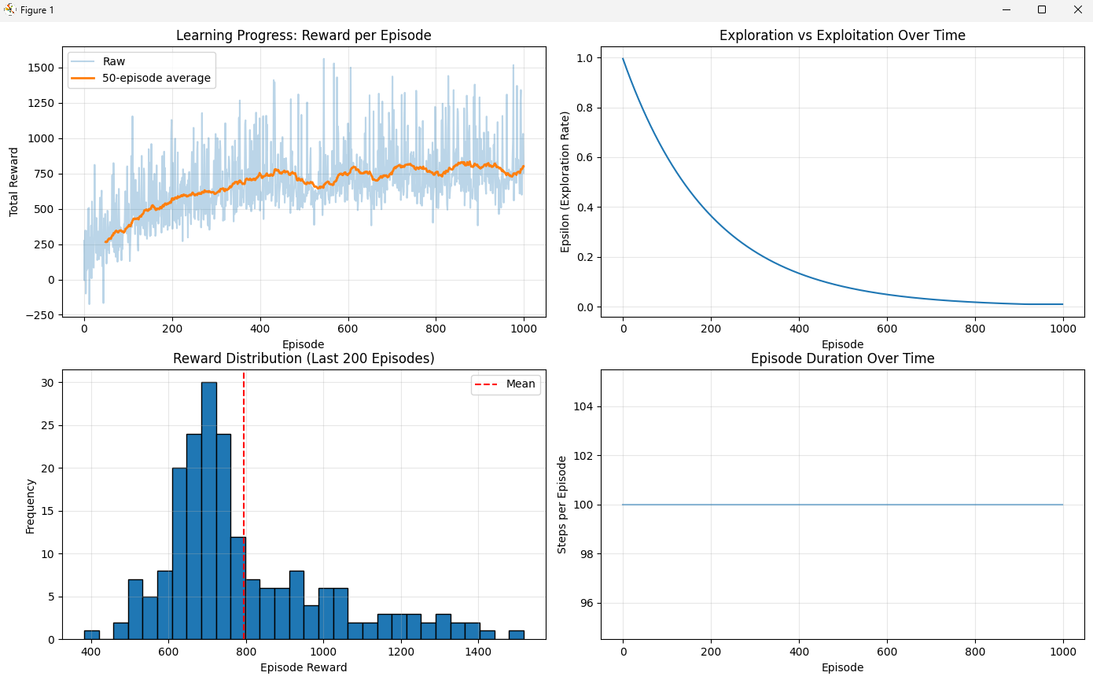

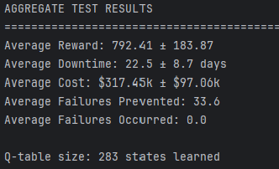

TESTING TRAINED AGENT
======================================================================

--- Test Episode 1 ---
Step 0 | Action: Schedule 3d | Reward: 5.0 | Priority: 0.25
Step 20 | Action: Schedule 7d | Reward: 8.0 | Priority: 0.24
Step 40 | Action: Schedule 7d | Reward: 8.0 | Priority: 0.22
Step 60 | Action: Low-Load | Reward: 13.1 | Priority: 0.25
Step 80 | Action: Low-Load | Reward: 13.1 | Priority: 0.25

Episode 1 Results:
Total Reward: 984.94
Total Downtime: 29.0 days
Total Cost: $323.61k
Failures Prevented: 51
Failures Occurred: 0

--- Test Episode 2 ---
Step 0 | Action: Immediate | Reward: 1.6 | Priority: 0.17
Step 20 | Action: Low-Load | Reward: 7.9 | Priority: 0.17
Step 40 | Action: Immediate | Reward: -0.7 | Priority: 0.16
Step 60 | Action: Schedule 7d | Reward: 8.0 | Priority: 0.13
Step 80 | Action: Schedule 7d | Reward: 8.0 | Priority: 0.14

Episode 2 Results:
Total Reward: 671.55
Total Downtime: 17.5 days
Total Cost: $309.32k
Failures Prevented: 23
Failures Occurred: 0

--- Test Episode 3 ---
Step 0 | Action: Low-Load | Reward: 12.4 | Priority: 0.28
Step 20 | Action: Low-Load | Reward: 12.4 | Priority: 0.24
Step 40 | Action: Low-Load | Reward: 12.4 | Priority: 0.24
Step 60 | Action: Immediate | Reward: 1.9 | Priority: 0.23
Step 80 | Action: Schedule 7d | Reward: 8.0 | Priority: 0.22

Episode 3 Results:
Total Reward: 1011.23
Total Downtime: 31.5 days
Total Cost: $295.05k
Failures Prevented: 59
Failures Occurred: 0

--- Test Episode 4 ---
Step 0 | Action: Do Nothing | Reward: -2.1 | Priority: 0.13
Step 20 | Action: Schedule 7d | Reward: 8.0 | Priority: 0.12
Step 40 | Action: Schedule 7d | Reward: 8.0 | Priority: 0.12
Step 60 | Action: Schedule 7d | Reward: 8.0 | Priority: 0.12
Step 80 | Action: Schedule 3d | Reward: 5.0 | Priority: 0.11

Episode 4 Results:
Total Reward: 530.35
Total Downtime: 8.0 days
Total Cost: $177.64k
Failures Prevented: 8
Failures Occurred: 0

--- Test Episode 5 ---
Step 0 | Action: Immediate | Reward: 23.3 | Priority: 0.40
Step 20 | Action: Schedule 7d | Reward: 8.0 | Priority: 0.38
Step 40 | Action: Schedule 7d | Reward: 8.0 | Priority: 0.39
Step 60 | Action: Schedule 3d | Reward: 5.0 | Priority: 0.38
Step 80 | Action: Schedule 7d | Reward: 8.0 | Priority: 0.38

Episode 5 Results:
Total Reward: 764.00
Total Downtime: 26.5 days
Total Cost: $481.61k
Failures Prevented: 27
Failures Occurred: 0

